# User Documentation

## System Overview

The system is used to manage queen alia airport data’s technically so that we can save a lot of time and effort in managing the airport. I flossed the requirements to build the database that will be beneficial used making the data that will help in running the airport and the airport from all parts. The system includes all the stakeholders in the airport such as the flights, passenger’s, stuff, boarding operations, managers and all the departments of the airport. To make the system I take in consideration all the data and requirements such as the relationship between the entities, logical design, physical design, conceptual design, schema and the interfaces of the system and the privileges that should be taken for each user of the system. And I convert all these information’s to a real interface that the user could deal with to manage the actual database of the airport and to take place in using the system. I made 4 users which are the passengers, staff, flight managers and the airport managers and made the interface that they will deal with in making any task and to manipulate the data.

## Using the system

**Note**: describe the system by its pages and functionalities per users. You need to add screenshots.

I made an interface for the manager who will have the widest privilege in the airport, the manager of the airport user will have the ability to use the interface by opening the software and after he opens the software, he will see the following.

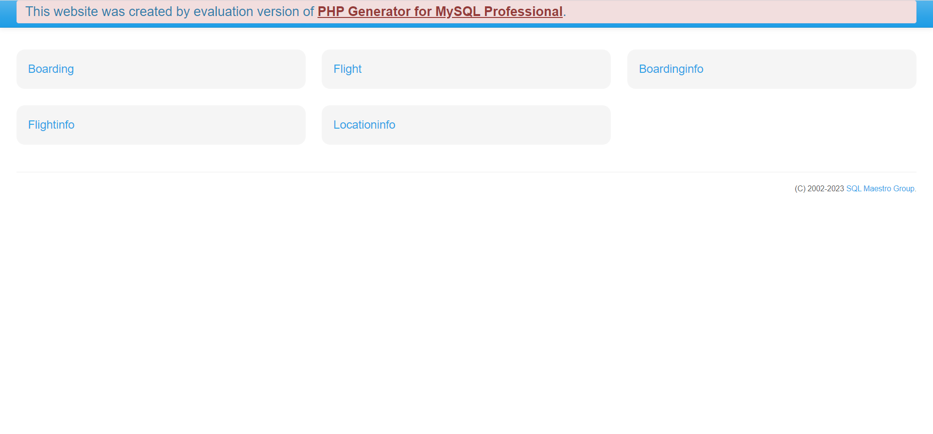

This picture shows all the tables and the data that the manager could reach in the airport and he could manipulate some of these data and he could also just view some of these data.

1. In the boarding: if the manager of the airport press the boarding the software will show him the following

So this show that the manager of the airport could view the data in this table and he could also update it.

1. If the manager of the airport press in the flight he will se this

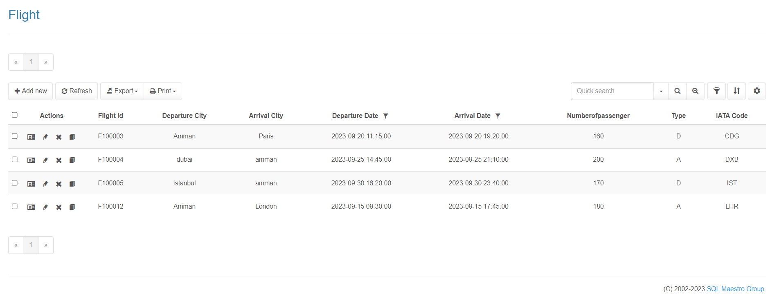

This show that the manager could view the table of the flights, he could also insert any new flight if he wants, he also could update the data in the table and he could delete any data from this table.

1. If the manager press on any of BoardingInfo,LocationInfo,FlightInfo he could view the tables that is a view to show several data between the entities in one table.

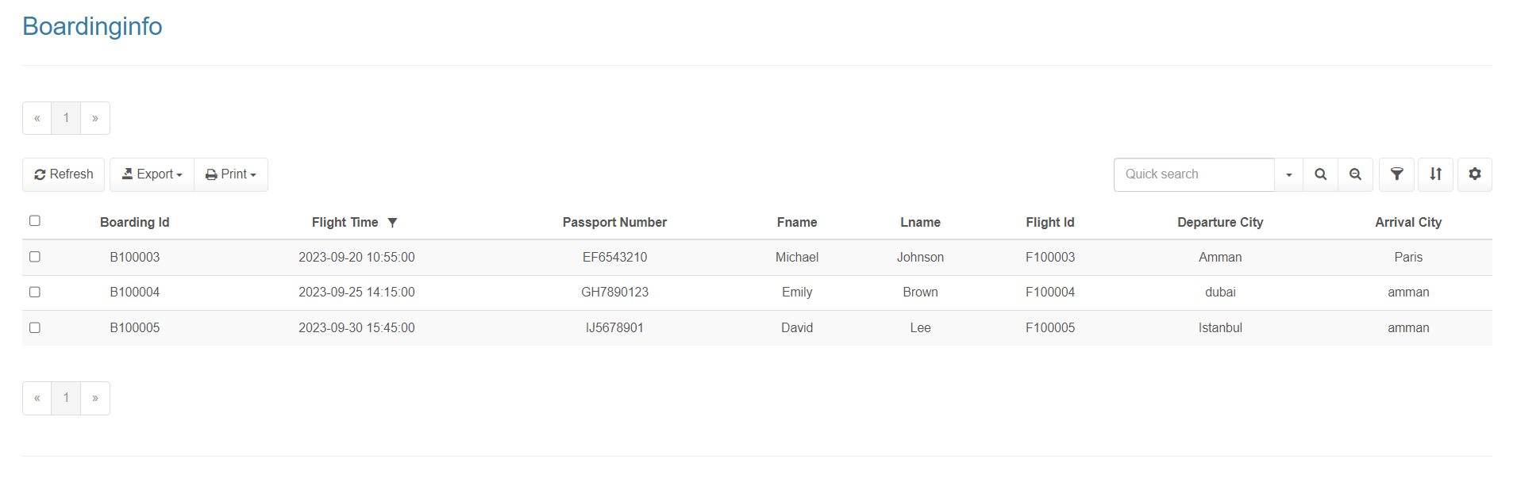

## Frequently asked questions

The people could ask a lot of questions about this system.

1. What is the purpose of this software?
2. Is there a demo version of the system?
3. What operating system does it support?
4. Does the system work 24 hours a day?
5. How much does this system cost?
6. Does the system include all the information that the airport could need?
7. Is there technical support in the system?
8. Is there a video show us how to use the system?
9. Is this system just for specific users?
10. Is there any limitation in this software?

## Contact information

1. User support email:

[support@databasecompany.com](mailto:support@databasecompany.com)

1. Technical support

[Techsupport@gmail.com](mailto:Techsupport@gmail.com)

1. Customer support phone number:

0790000888